# CS 255 System Design Document Template

This template lays out all the different sections that you need to complete for Project Two. Each section has guidance to prompt your thinking. You will need to continually reference the interview transcript as you work to make sure that you are addressing your client’s needs. There is no required length for the final document. Instead the goal is to complete each section based on what your client’s needs are. Remove this note when you are finished, and replace all bracketed text with the relevant information.

## UML Diagrams

### UML Use Case Diagram

### UML Activity Diagrams

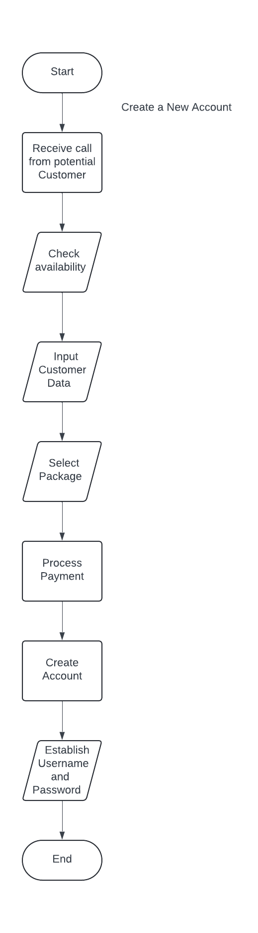

### UML Sequence Diagram

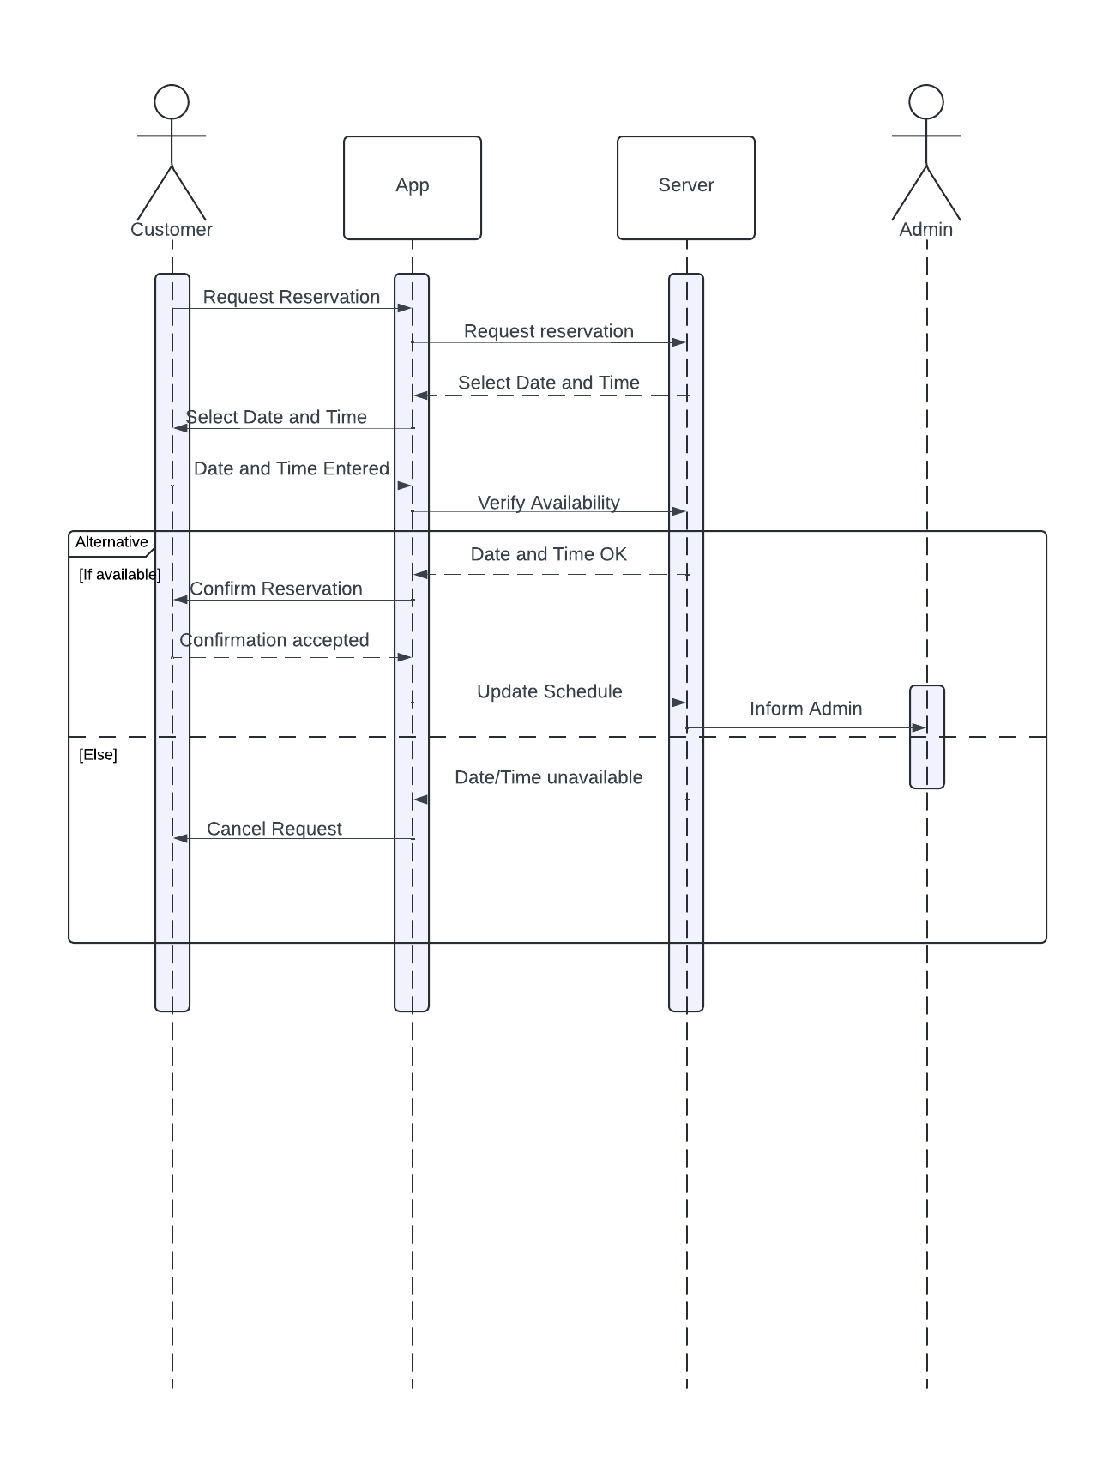

### UML Class Diagram

## Technical Requirements

For this system to function with efficiency and to minimize the time needed to train future employees I would recommend the following technical requirements. I would recommend the use of Java to write your system. Using Java will allow for easier crossover between differing operating systems. I would recommend the use of Windows OS. This will minimize training on the different operating systems as well as having access to multiple third-party tools. As requested by the owner, the server will be managed by a cloud server. Google servers offer great protection as well as frequent maintenance offering reliability for your system.